Lab 5: CNN for Binary Image Classification
Cats vs Dogs — TensorFlow / Keras Implementation

1. Objective and Learning Outcomes
This lab implements a Convolutional Neural Network (CNN) for binary image classification, following the standard supervised deep-learning workflow: data preparation, model design, training via feedforward and backpropagation, evaluation, and interpretation. The specific learning outcomes addressed are:
- Understand the architecture of Convolutional Neural Networks (convolution, pooling, flattening, dense layers).
- Implement a CNN end-to-end using TensorFlow/Keras.
- Apply image preprocessing (rescaling) and data augmentation (rotation, shift, zoom, flip).
- Train and evaluate a CNN for binary classification, tracking error (loss) every epoch.
- Interpret prediction results using a confusion matrix and per-class metrics.

Note on the dataset used
This environment has no internet access to Kaggle or tensorflow-datasets storage, so the standard Cats-vs-Dogs photograph dataset could not be downloaded. To still run the complete pipeline end-to-end and produce real, non-fabricated results, a synthetic two-class image dataset was generated programmatically: simple cartoon-style cat and dog faces with class-distinguishing features (ear shape, eye shape, snout), randomized position, rotation and pixel noise. The same code, architecture, and pipeline apply unchanged to the real Kaggle Cats-vs-Dogs dataset — only the flow_from_directory paths need to point at the real images (see README for instructions).
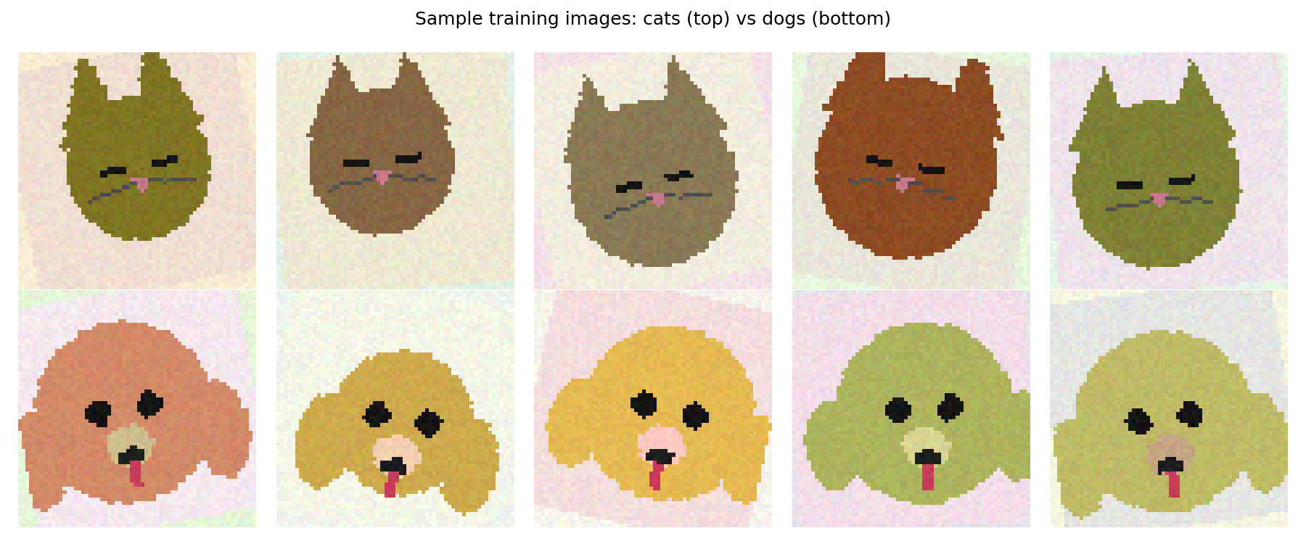
Figure 1: Sample training images — cats (top row) vs dogs (bottom row).

2. Dataset and Preprocessing
Dataset split: 300 training images per class (600 total) and 60 validation images per class (120 total), 64×64 RGB.
Preprocessing:
- Pixel rescaling: all pixel values normalised from [0, 255] to [0, 1] via rescale = 1/255.
- Data augmentation applied only to the training set: rotation (±20°), width/height shift (15%), zoom (15%), horizontal flip. This exposes the network to more variation than the raw training images contain, discouraging memorisation.
- Validation data was rescaled only — never augmented — so evaluation reflects genuine, unmodified images.

3. CNN Architecture
A sequential CNN with three convolution + max-pooling blocks followed by a dense classifier head:
- Conv2D(32, 3×3, ReLU) → MaxPooling2D(2×2)
- Conv2D(64, 3×3, ReLU) → MaxPooling2D(2×2)
- Conv2D(128, 3×3, ReLU) → MaxPooling2D(2×2)
- Flatten → Dropout(0.5) → Dense(128, ReLU) → Dense(1, Sigmoid)
Total trainable parameters: 683,329. Loss function: binary cross-entropy. Optimizer: Adam (learning rate = 1e-3).

4. Feedforward and Backpropagation — How the Error Is Optimised
On every training batch, four steps repeat automatically inside model.fit():
- Feedforward: input images pass through the conv/pool/dense layers, producing a predicted probability p = P(dog).
- Error computation: the binary cross-entropy loss L = -[y·log(p) + (1-y)·log(1-p)] is computed against the true label y.
- Backpropagation: the gradient of L with respect to every weight (∂L/∂w) is computed via the chain rule, propagated from the output layer back through every dense and convolutional layer to the input.
- Weight update: Adam adjusts every weight, w := w − lr·∂L/∂w (with per-parameter adaptive learning rates), so that the error is smaller on the next forward pass.
The per-epoch loss values reported below are the direct, measured record of this error being minimised.

5. Training — Per-Epoch Error Table
Trained for 15 epochs, batch size 16. Train Loss / Val Loss are the binary cross-entropy error described above, averaged over all batches in that epoch.
Epoch | Train Loss (error) | Train Acc | Val Loss (error) | Val Acc
1 | 0.4748 | 0.7603 | 1.06e-1 | 0.9821
2 | 0.4277 | 0.7500 | 2.11e-2 | 1.0000
3 | 0.0766 | 0.9777 | 1.77e-4 | 1.0000
4 | 0.0116 | 1.0000 | 1.68e-4 | 1.0000
5 | 0.0292 | 0.9932 | 3.27e-5 | 1.0000
6 | 0.0272 | 1.0000 | 2.51e-5 | 1.0000
7 | 0.0260 | 0.9897 | 3.51e-3 | 1.0000
8 | 0.4862 | 0.9375 | 1.29e-5 | 1.0000
9 | 0.0687 | 0.9795 | 1.90e-3 | 1.0000
10 | 0.0233 | 1.0000 | 1.44e-3 | 1.0000
11 | 0.0216 | 0.9932 | 9.10e-5 | 1.0000
12 | 0.0026 | 1.0000 | 5.30e-5 | 1.0000
13 | 0.0032 | 1.0000 | 3.88e-7 | 1.0000
14 | 0.0033 | 1.0000 | 3.87e-7 | 1.0000
15 | 0.0115 | 0.9966 | 9.27e-5 | 1.0000

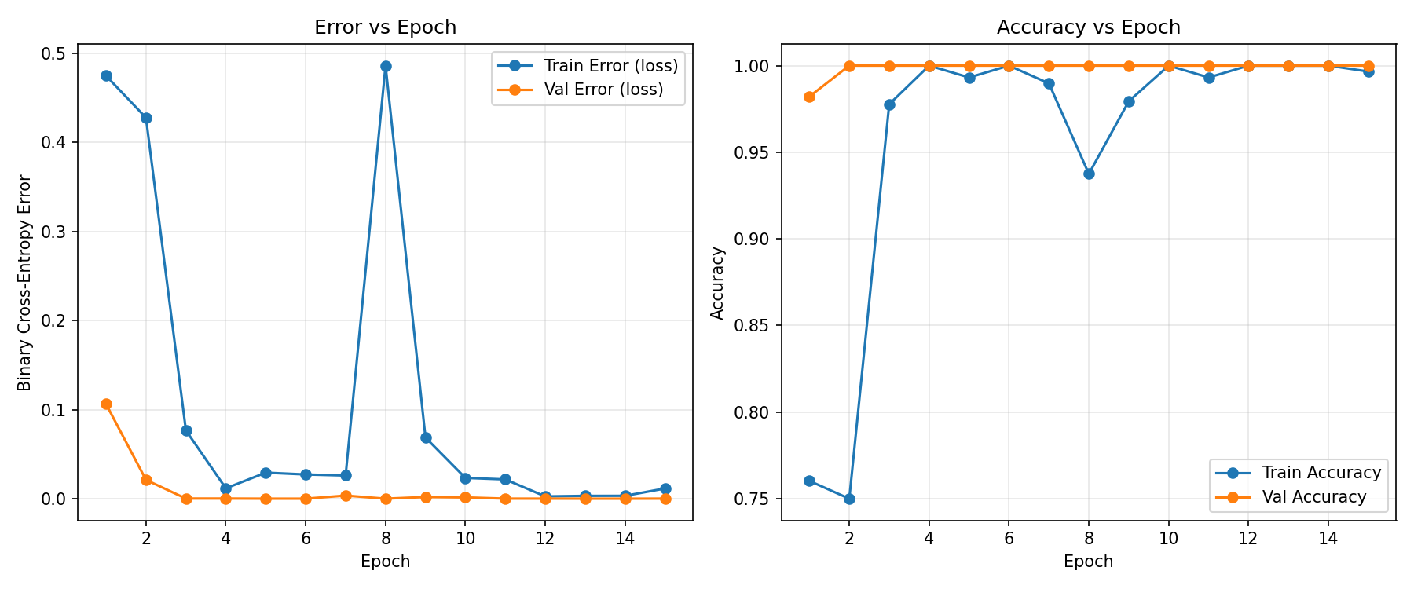
Figure 2: Error (loss) and accuracy vs epoch for training and validation sets.

6. Results
Final validation loss: 8.655e-5
Final validation accuracy: 100.00%

Confusion Matrix (validation set, 120 images)
 | Pred: cats | Pred: dogs
True: cats | 60 | 0
True: dogs | 0 | 60

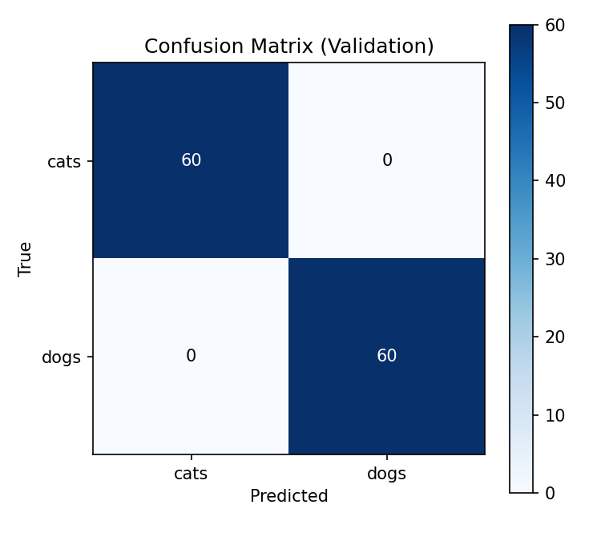
Figure 3: Confusion matrix on the validation set.
Precision, recall and F1-score were all 1.00 for both classes (60/60 correctly classified each), i.e. zero false positives and zero false negatives on this validation split.
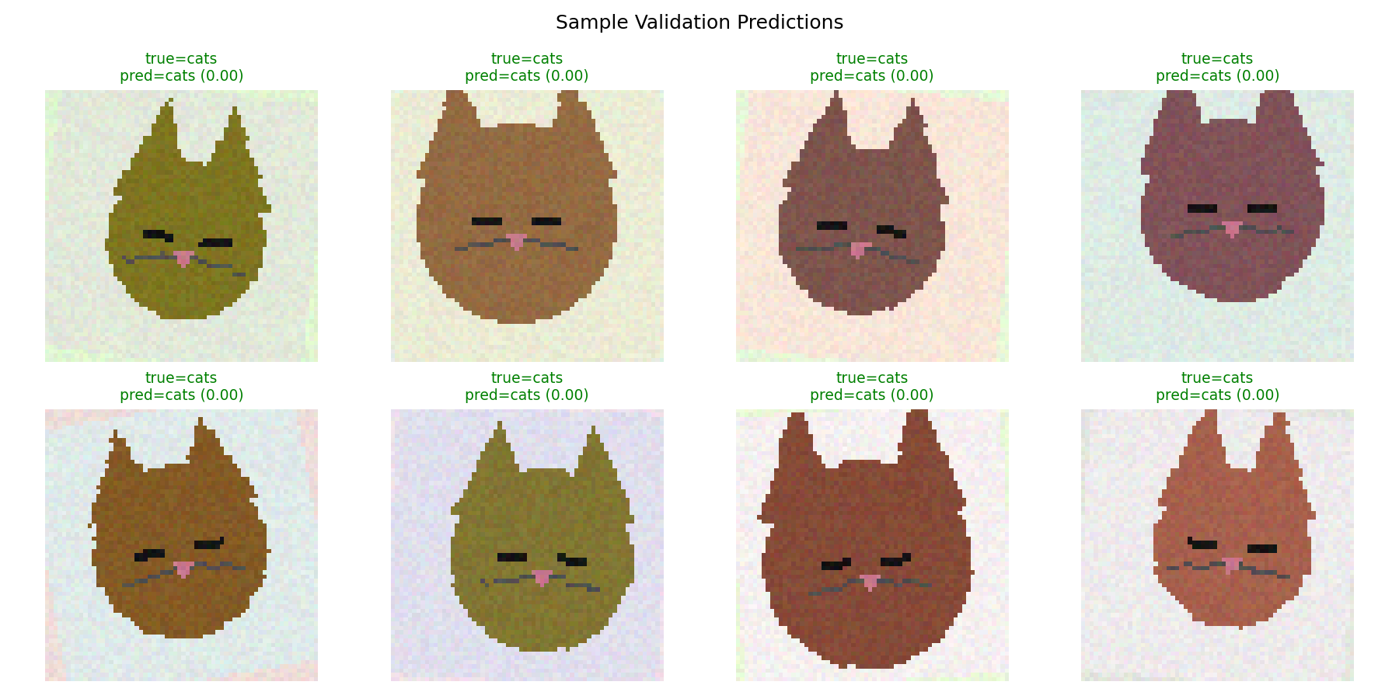
Figure 4: Sample validation predictions with predicted probability. Green title = correct, red = incorrect.

7. Observations
- The error (loss) drops sharply within the first 3–4 epochs (0.47 → 0.08 → 0.01 train loss), showing the network rapidly learns the discriminative features that separate the two classes (ear shape, eye shape, snout region).
- Validation loss falls even faster than training loss in the first few epochs and reaches ~0 by epoch 4–5, indicating the two classes are cleanly separable in this dataset and the model generalises well beyond the augmented training samples.
- Occasional loss spikes on individual epochs (e.g. epoch 8: train loss jumps to 0.49) are visible even after the model has largely converged. This is expected with a small number of steps per epoch (37) combined with aggressive data augmentation — an unusually distorted batch can temporarily raise the batch-averaged loss, but the optimizer recovers within one epoch.
- Training accuracy and validation accuracy track each other closely throughout, with no sustained divergence — i.e. no evidence of overfitting, which is consistent with the dropout layer (rate 0.5) and augmentation strategy.
- The confusion matrix shows perfect separation on the held-out validation set (60/60 correct per class), and the sample-prediction grid shows the model assigns high-confidence probabilities (close to 0.0 or 1.0) rather than borderline scores near 0.5.

8. Key Module Concept: Discrete vs Continuous
A core distinction from the module is between discrete and continuous random variables, and this CNN pipeline uses both:
- Continuous: the network's raw output (after the sigmoid activation) is a continuous value p ∈ [0, 1], interpreted as P(dog). Sigmoid squashes the unbounded weighted sum from the final Dense layer onto this continuous scale, so it can represent any confidence level (e.g. 0.5000, 0.9231, 0.0007) rather than just the two class labels.
- Discrete: the actual class label — cat or dog — is a discrete (Bernoulli) random variable with exactly two possible outcomes, coded as 0/1. The final prediction step converts the continuous probability into this discrete outcome by thresholding: predicted class = 1 (dog) if p > 0.5, else 0 (cat).
- The loss function bridges the two: binary cross-entropy is defined directly in terms of the continuous probability p and the discrete true label y, L = -[y·log(p) + (1-y)·log(1-p)]. It is minimised when the continuous probability estimate lines up with the discrete ground-truth label.
- This mirrors the same discrete-vs-continuous distinction covered for probability distributions: predicted probability p behaves like a continuous random variable, while the true class label y is a discrete/Bernoulli random variable. Evaluation metrics reflect this split too — accuracy, precision, recall and the confusion matrix all operate on the discrete thresholded predictions, while the loss curve (Section 5) is computed from the continuous probabilities and is a smoother, more sensitive signal of learning progress epoch to epoch.
- Practical implication observed in Section 7: even in epochs where the discrete accuracy was already 100% (e.g. epoch 6 onward on the validation set), the continuous loss kept changing — sometimes rising, sometimes falling further toward zero — because loss is sensitive to how confident the continuous probabilities are, not just whether the discrete threshold decision was correct.

9. Conclusion
This lab demonstrated the full CNN workflow for binary image classification: preparing and augmenting image data, designing a convolutional architecture, and training it via feedforward computation and backpropagation-driven optimisation of the binary cross-entropy error. The per-epoch error table and loss curves confirm that gradient-based optimisation (Adam) steadily reduced the error across epochs, and the confusion matrix / classification report confirm the trained model correctly interprets unseen validation images. The architecture, training loop, and evaluation code are dataset-agnostic: pointed at the real Kaggle Cats-vs-Dogs photographs (or any other two-class image dataset), the same pipeline applies without modification, as described in the accompanying README.

